

Atlantic Coast Exotics, LLC:
Paapri Cloud Technology
CASE TO RESOLUTION

Prerequisites:
Item Configuration:
NOTE: The user needs to check the checkbox of Offer Support in the Preference line field of that item in which he wants to give support.
Navigate: Lists->Accounting->Items. Click Edit on the Item and check the checkbox of Offer Support in the Preference line field of that item in which he wants to give support.
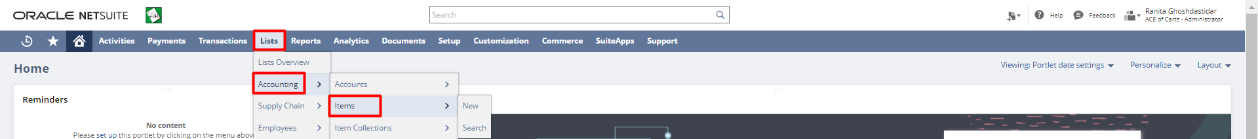
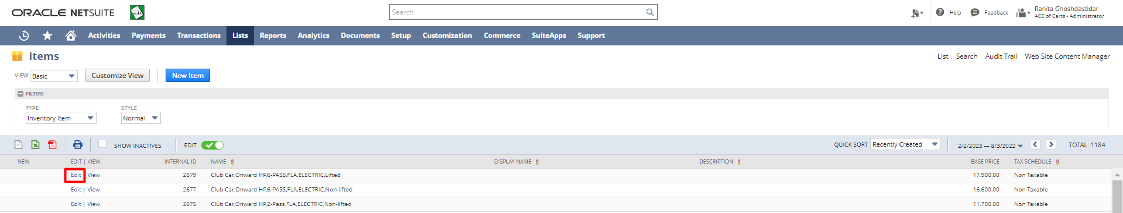
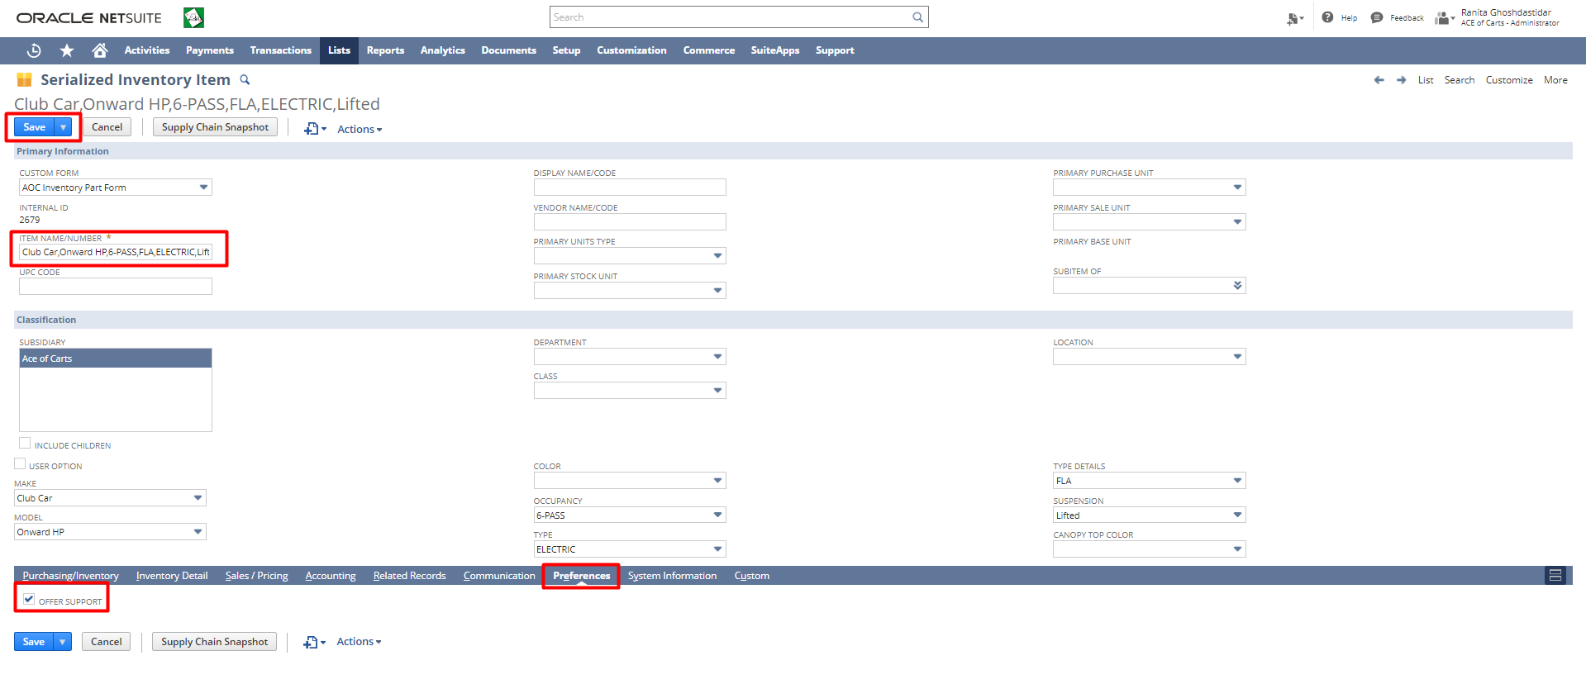
Employee Configuration:
NOTE: In order to select an employee for support, the user needs to make sure that the Employee selected has been provided with the role of Support Rep.
Navigate Lists->Employees-> Employees. Click Edit on the Employee and check the checkbox of Support Rep in the Human Resources line field of that employee, and save the record.
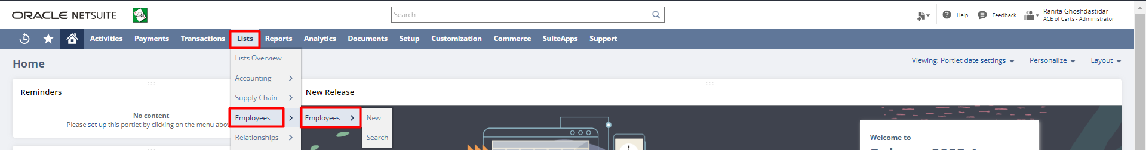
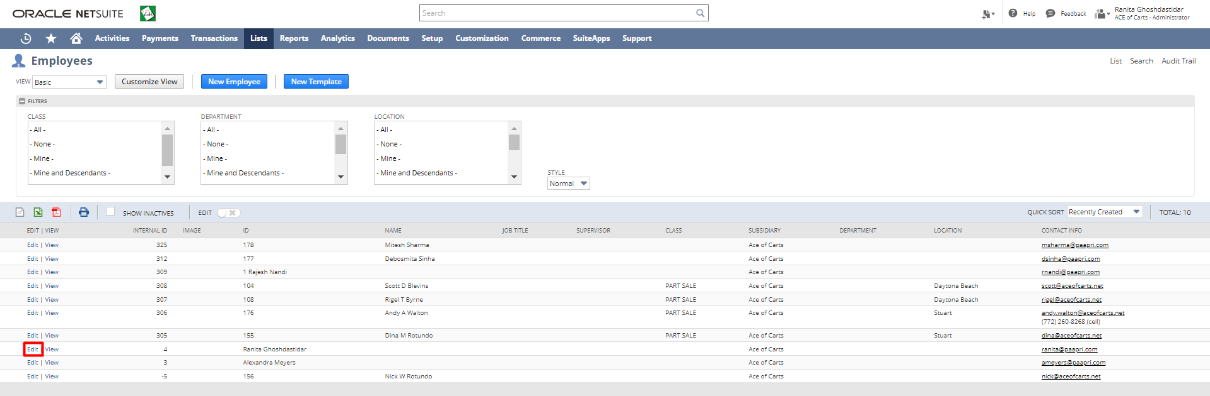
Support rep checkbox is checked.
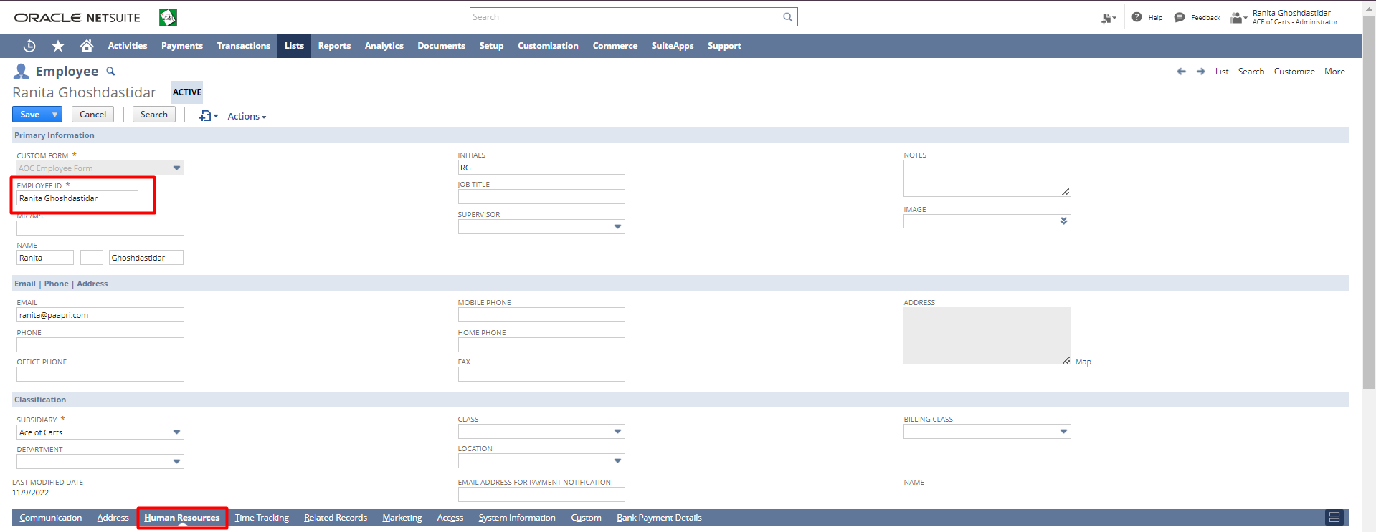
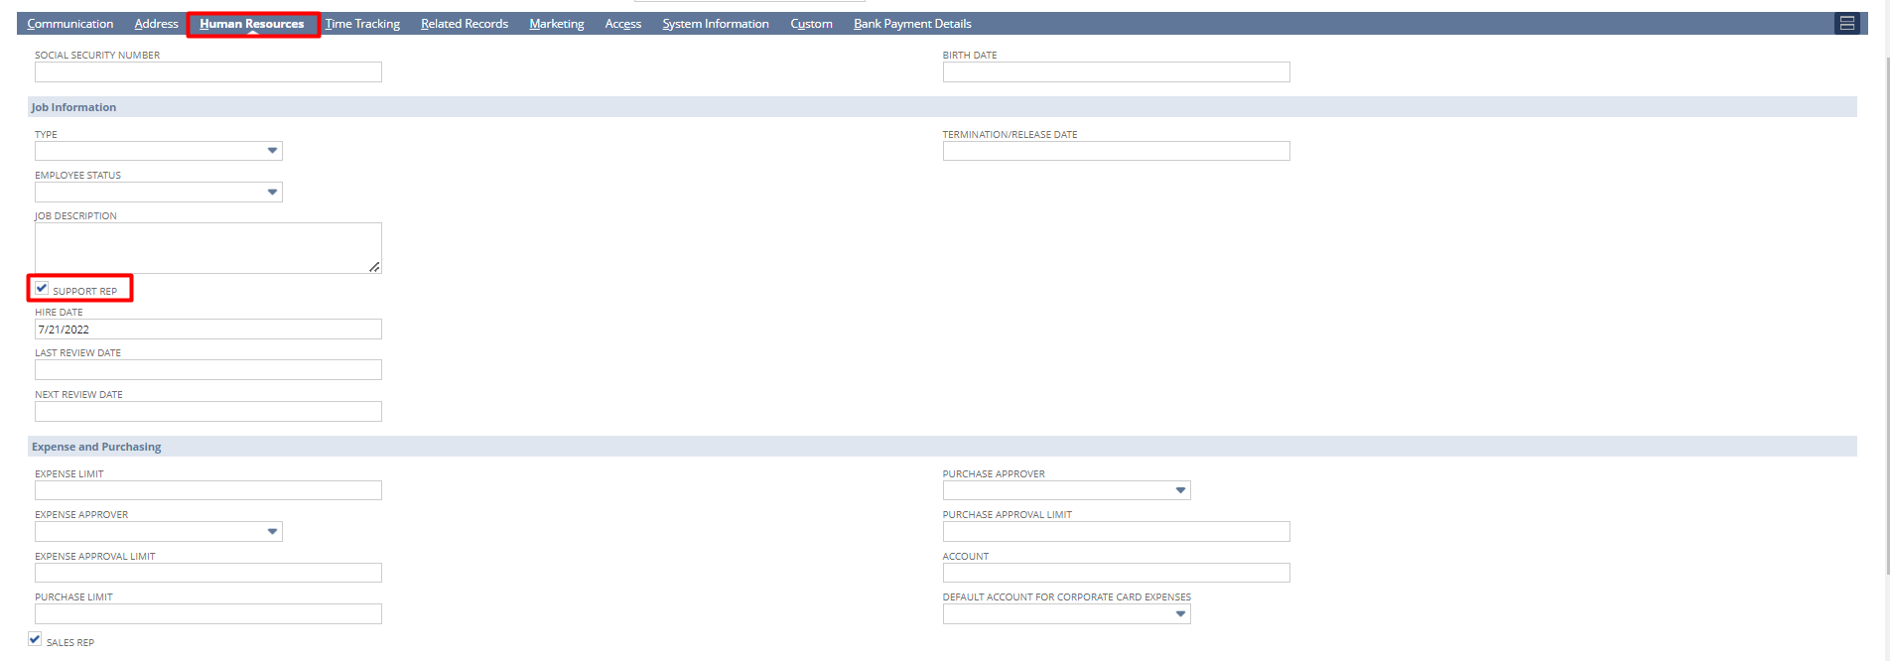
Case to Resolution
Creating a Case:
Step 1: The user needs to log in with the Administrator role.
Then navigate: lists -> Support -> Cases -> New.
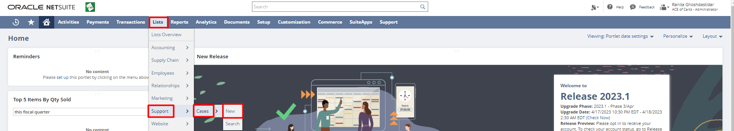
Step 2: Enter the Subject. Select the Company. Selecting the company sources the values for Profile, Subsidiary, Phone, and email for the company. Select the Status for the Case. Select the Priority. Enter a Quick Note if any. The Date and Time are taken automatically from the system. Select the Item from the dropdown, select the type of the case, select the Case Issue and then select the Origin.
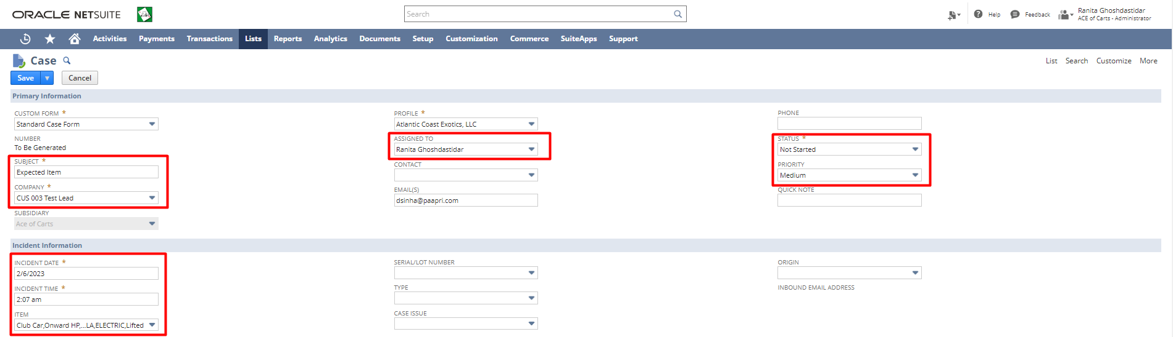
Step 3: Under the Communication subtab copy and paste the email from the customer in the Message field. Click the Save button.
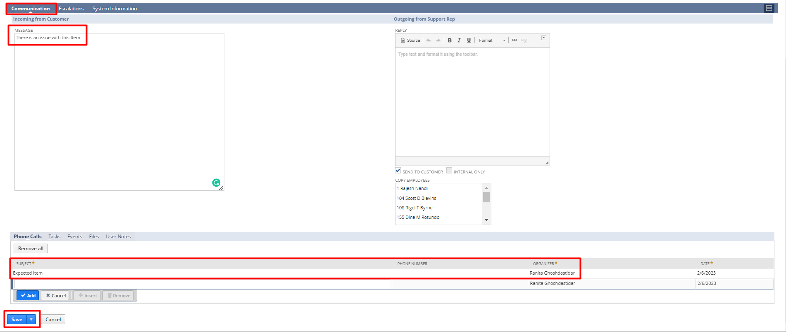
This creates a case in NetSuite.
Replying to a Case:
Step 1: Navigate: Lists->Support->Cases. Click Edit on the case you want to reply.
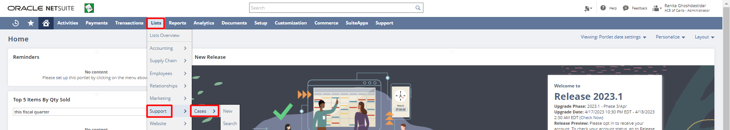
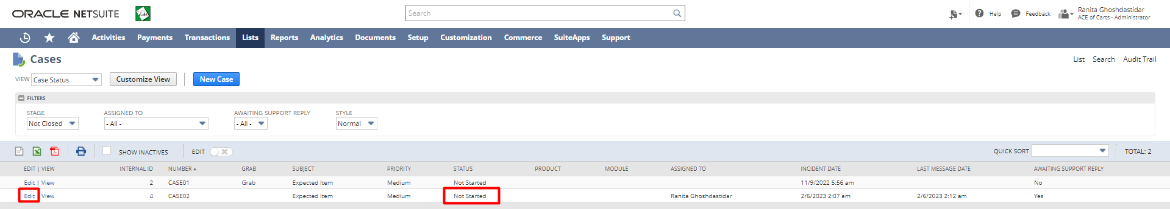
Step 2: Scroll down to the Communication subtab and in the Reply field enter the reply to the case. Check the Send to Customer checkbox. Then click the Save button. This sends a reply to the customer.
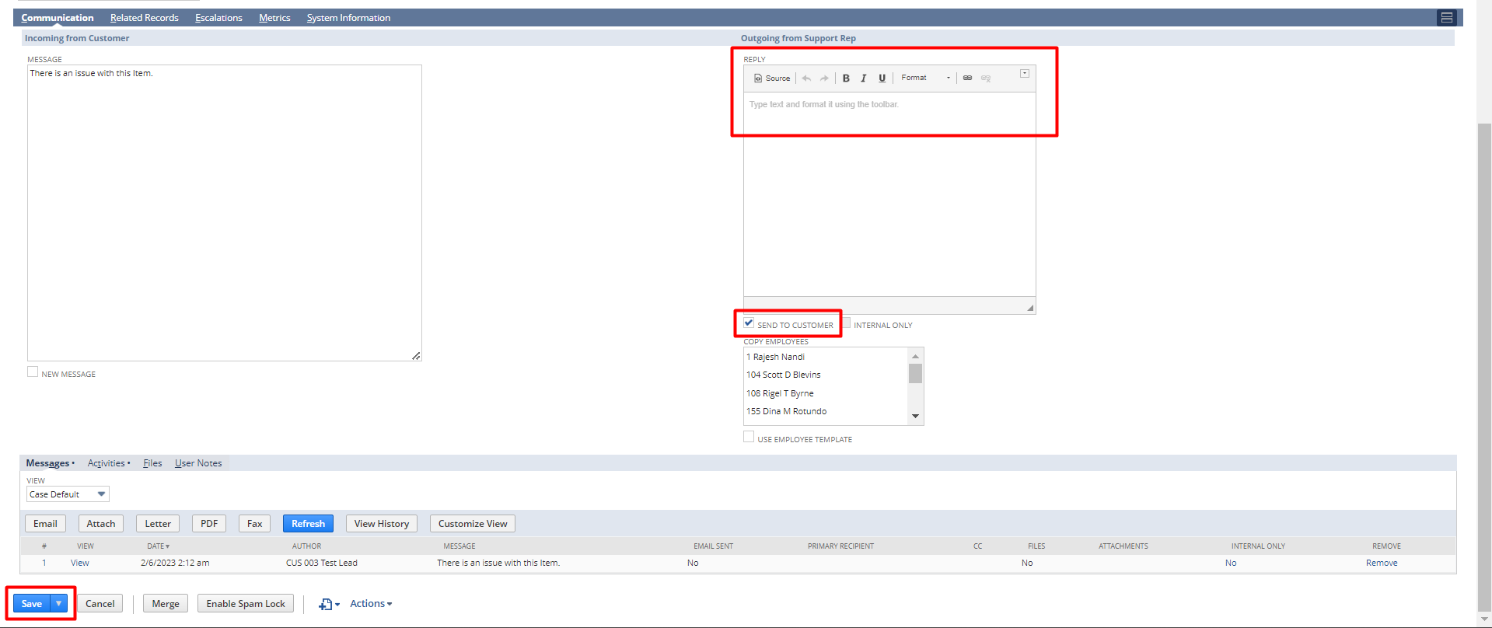

Escalation of Case:
Step 1: Navigate: Lists->Support->Cases. Click Edit on the case you want to Escalate.

Step 2: From the Status dropdown field select Escalated as the status.
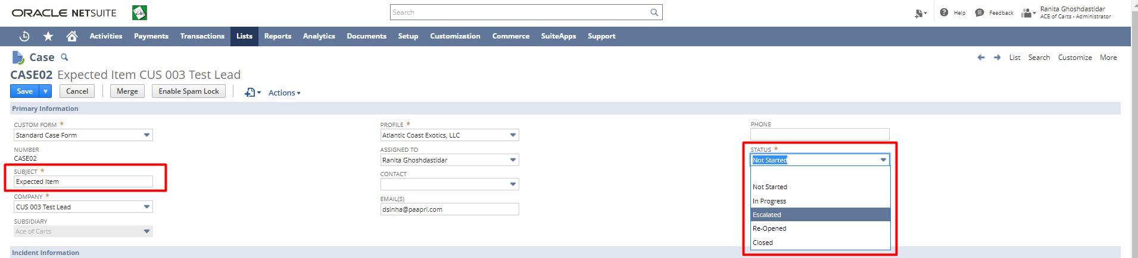
Step 3: Scroll down to Escalate To subtab. Add an escalation message if any in the Escalation Message field. From the Escalate dropdown select the support rep to whom you want to escalate this case. Click the Add button. Click the Save button.
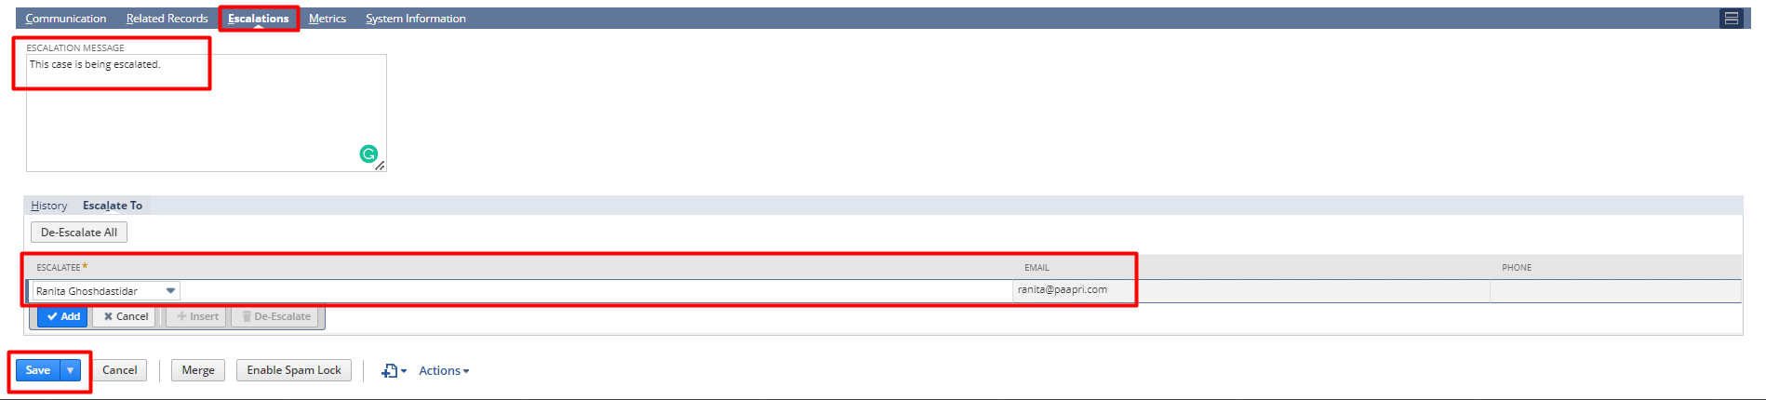
For Return/Replace the Item:
Click on the Search Transaction button in the View mode of a case.
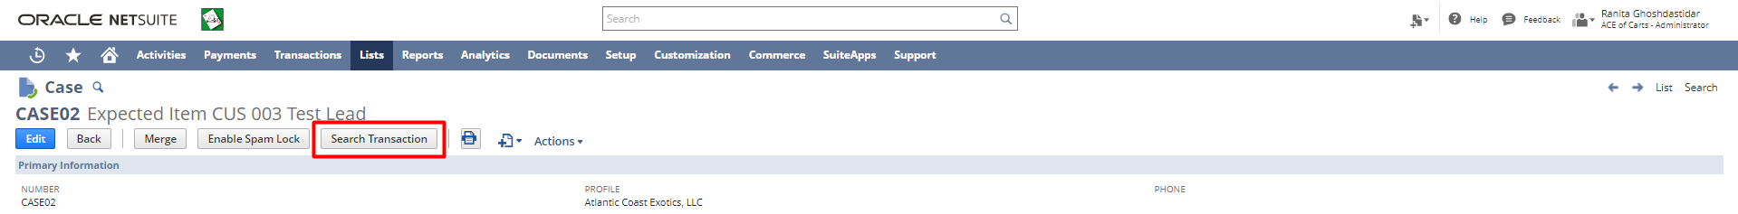
Select the sales order which user wants to return or replace or return.
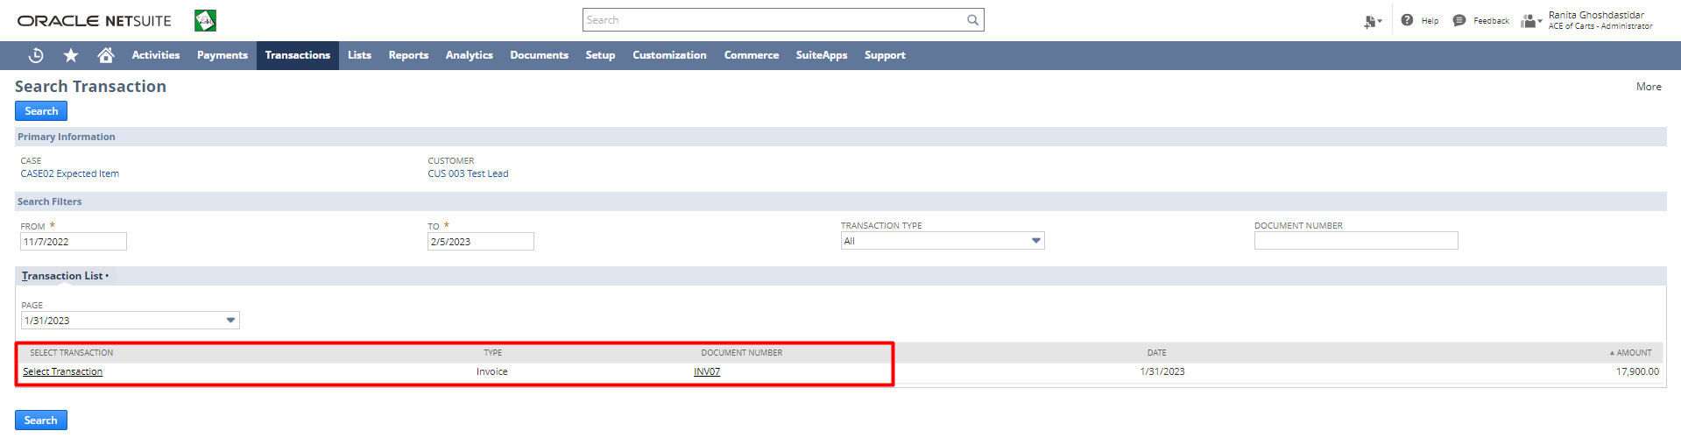
Select one of the options for Create Transaction. If the user opts for Return Authorization, the below steps are to be followed. 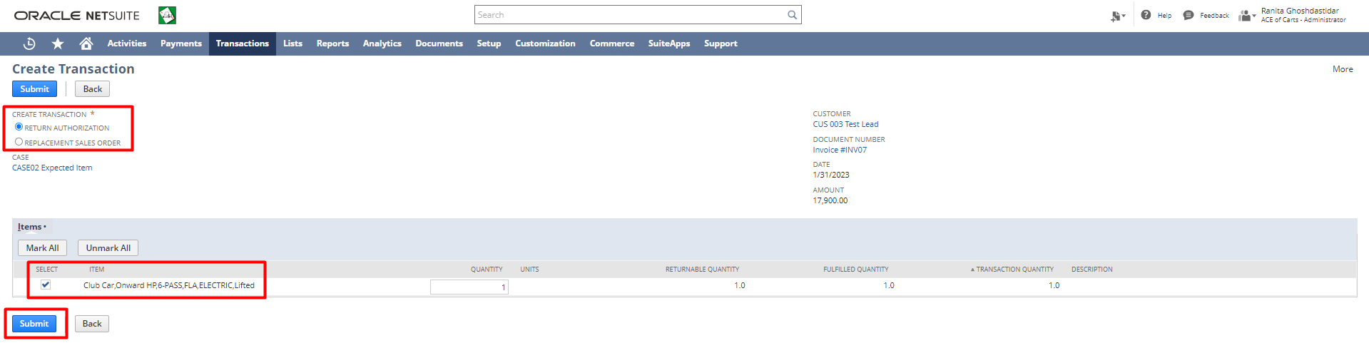
The user will be directed to the Return Authorization form. Click on the Save button.
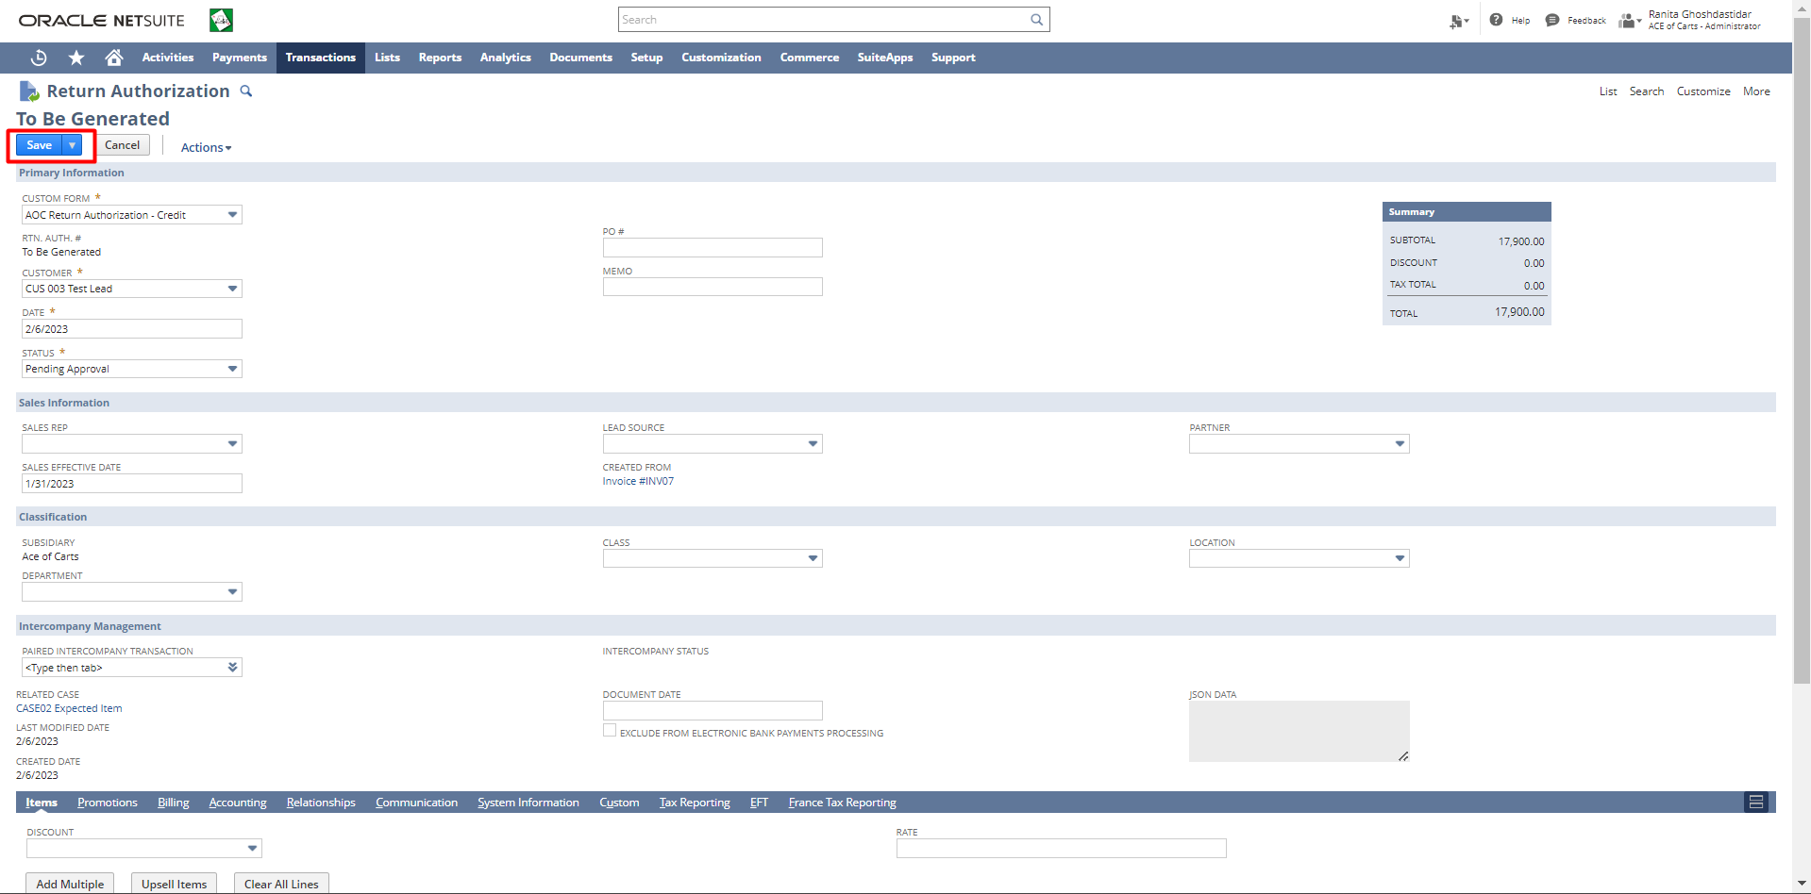
If the user opts for Replacement Sales Order, the below steps are to be followed. 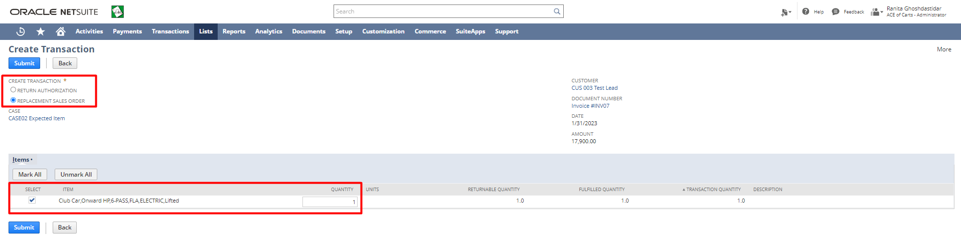
The user will be directed to the Sales Order form. If required the user can make the Sales Order value zero. Click on the Save button.
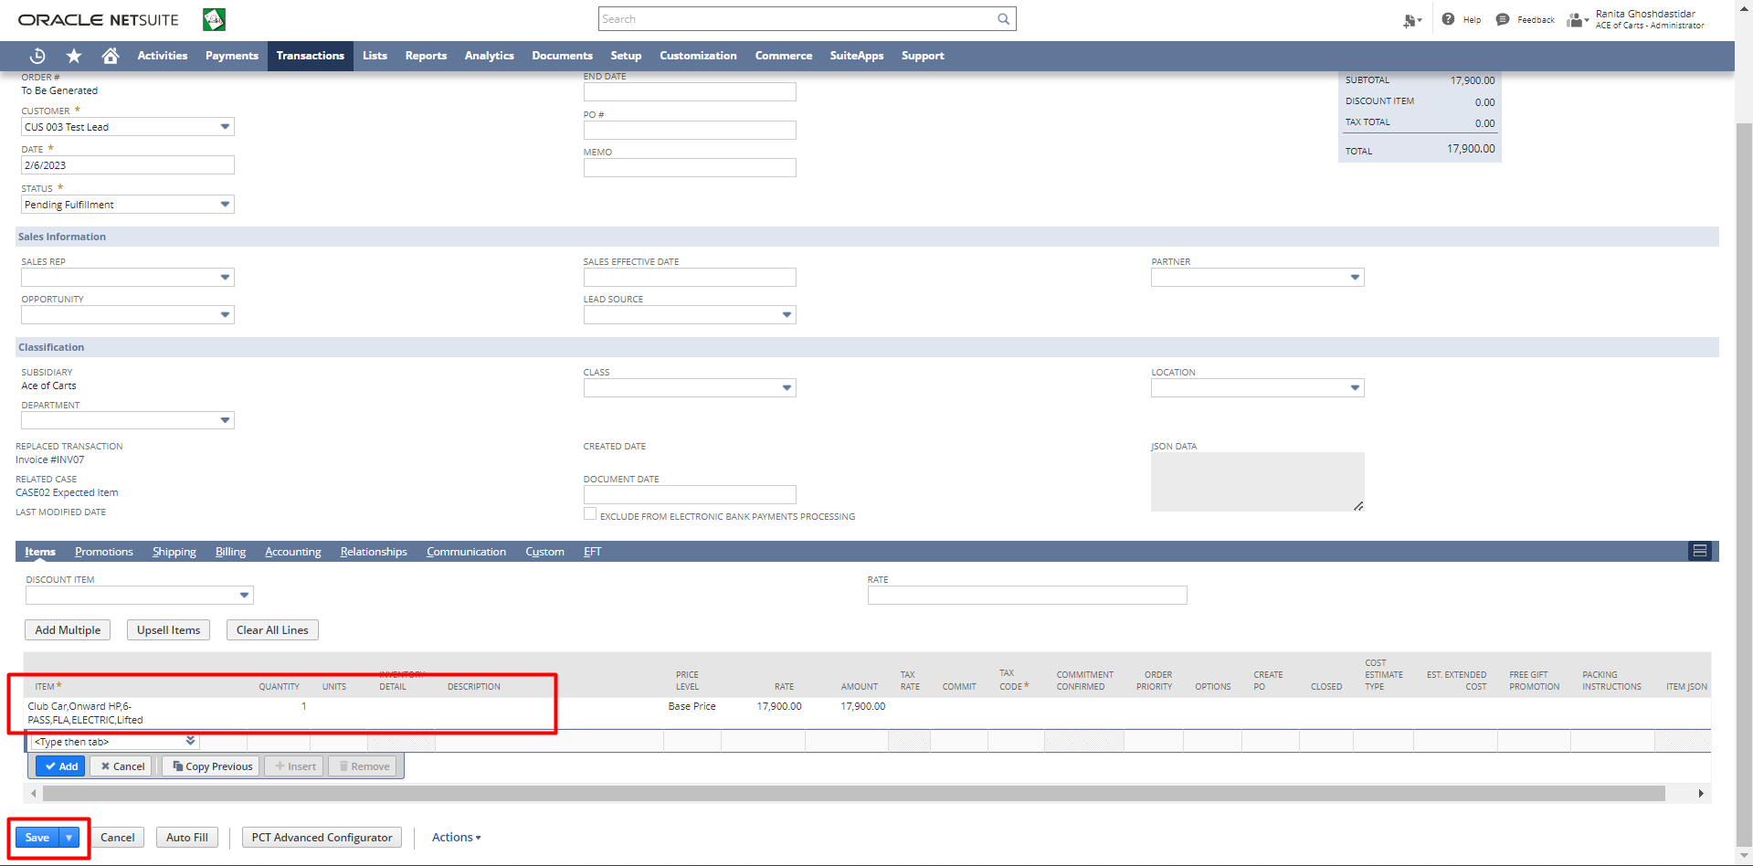

Signature: _____________________________ Date: ______________________

Disclaimer:
Upon signing off on the process flow document, you are confirming that the process has been set up per the SOW within NetSuite per your business's needs. Any changes or modifications requested after sign-off will need to be a "change request" at an additional fee.

*** PLEASE ensure that you have logged into NetSuite and tested the process prior to signing off on the setup. Paapri requires sign-off on this document prior to moving forward with any additional design meetings.

